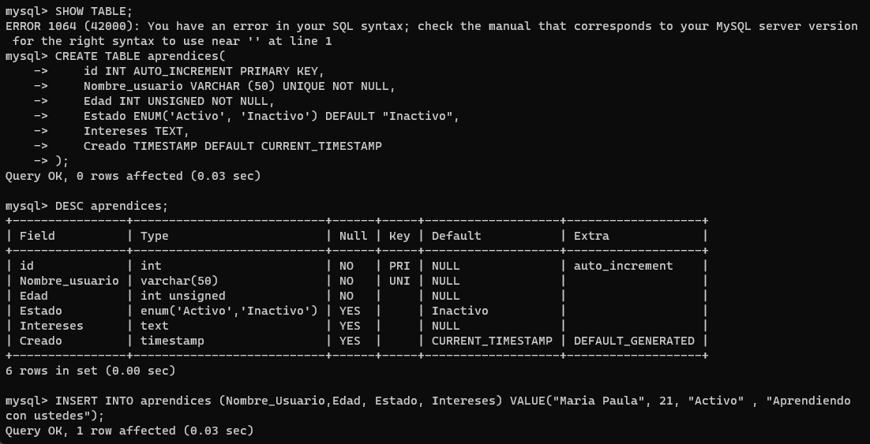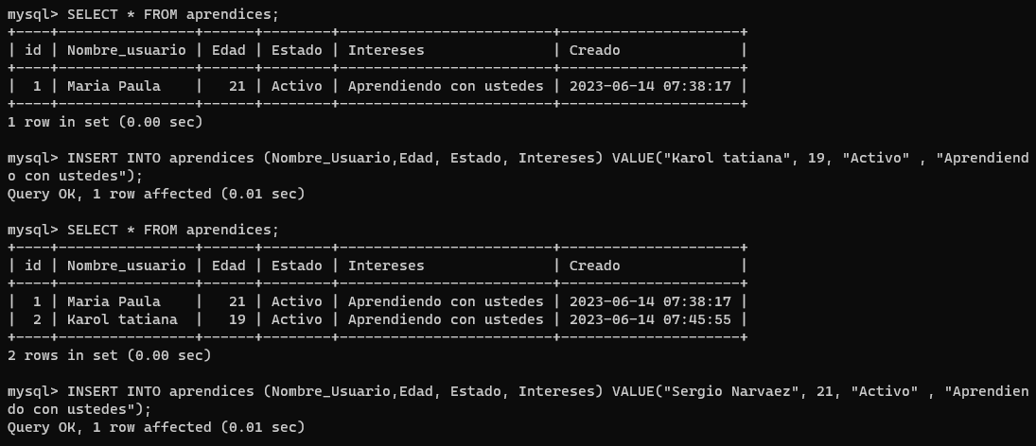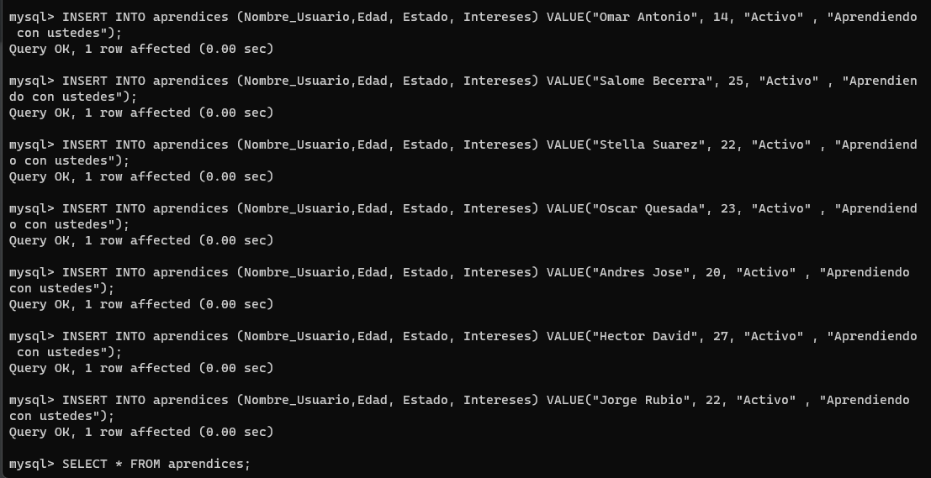EJERCICIO 1: CRUD

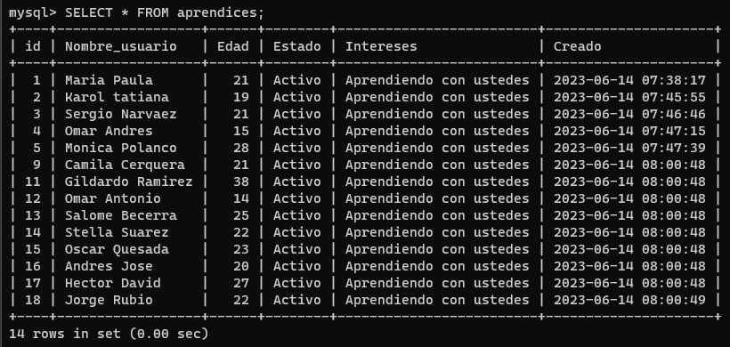

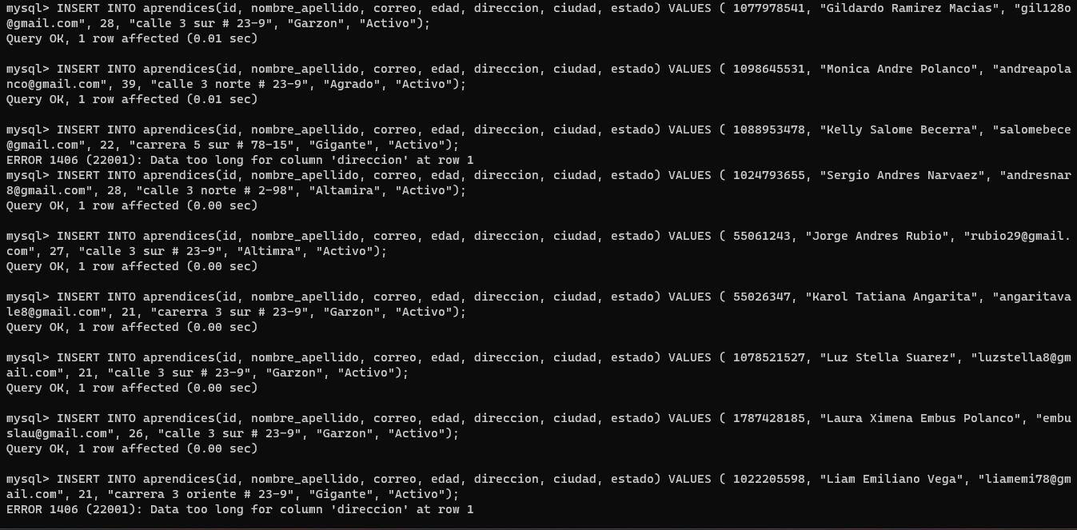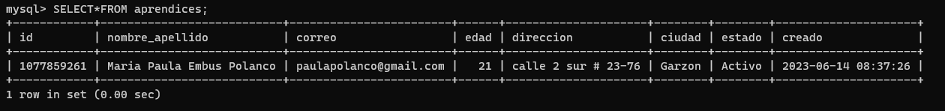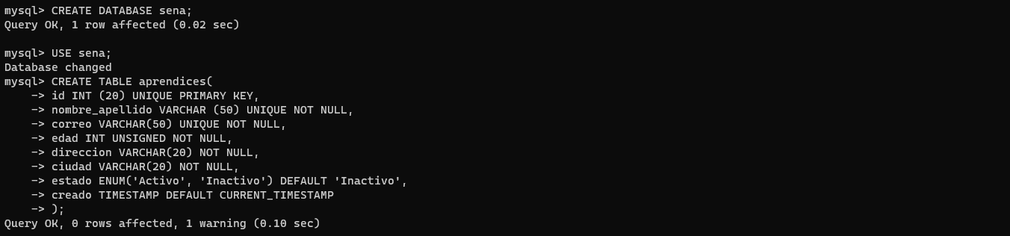EJERCICIO 2: CRUD

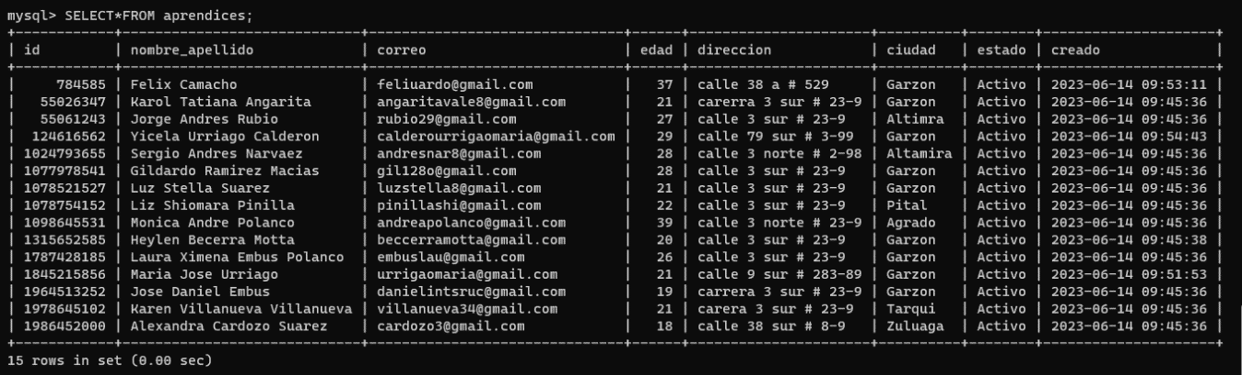

CASO 1: SELECT id FROM aprendices;

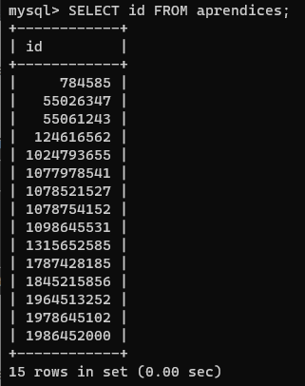

CASO 2: SELECT nombre_apellido, edad FROM aprendices;

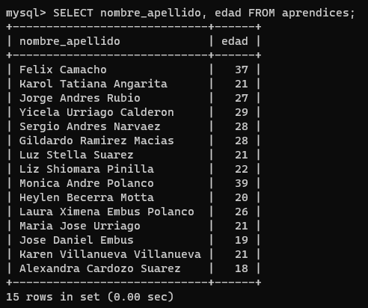

CASO 3: SELECT nombre_apellido, edad, estado FROM aprendices;

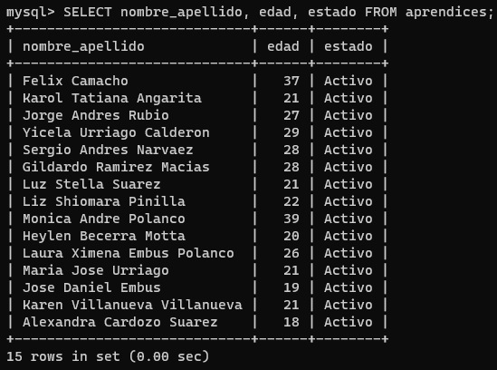

CASO 1: SELECT id FROM aprendices\G;

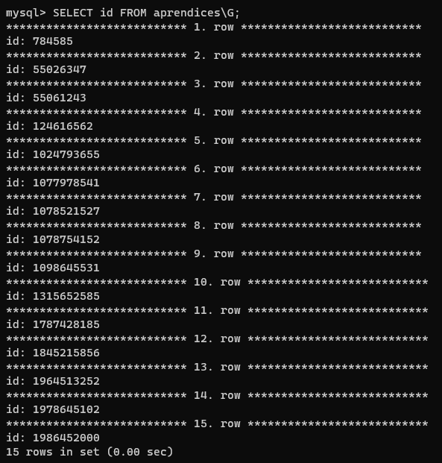

CASO 2: SELECT nombre_apellido, edad, estado FROM aprendices\G;

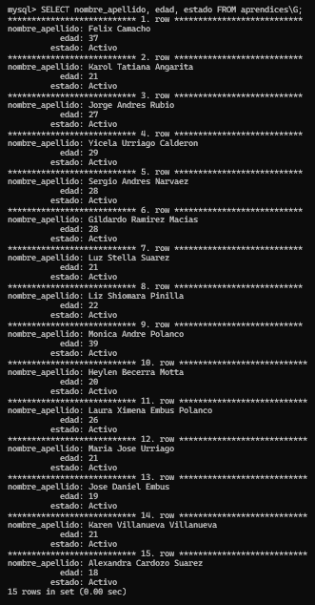

CASO 3: SELECT * FROM aprendices\G;

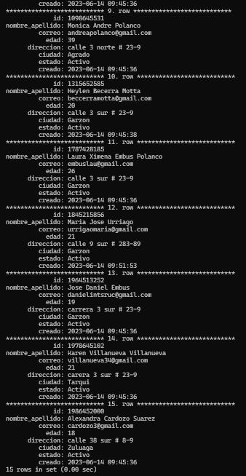

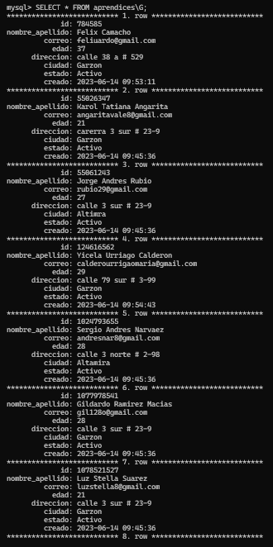

CASO 1: SELECT * FROM aprendices WHERE id = 1077978541;

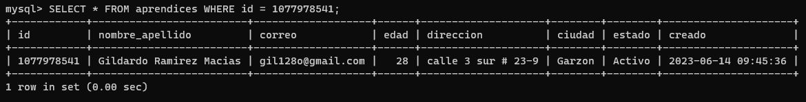

CASO 2: SELECT * FROM aprendices WHERE correo = ‘cardozo3@gmail.com;

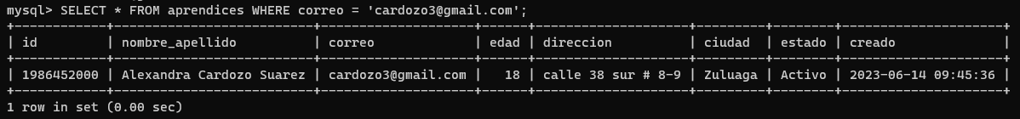

CASO 3: SELECT * FROM aprendices WHERE edad >= 24;

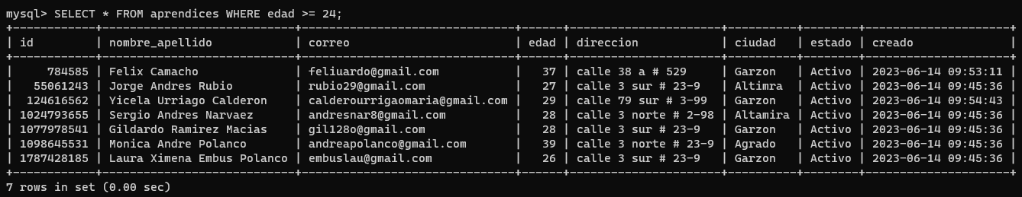

CASO 4: SELECT * FROM aprendices WHERE creado > ‘2023-06-14 00:00:01’;

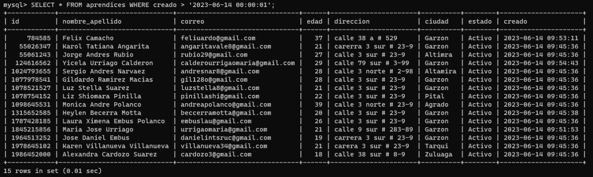

CASO 5: SELECT * FROM aprendices WHERE id IN (784585, 1098656631);

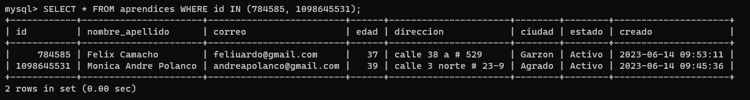

CASO 6: SELECT * FROM aprendices ORDER BY edad;

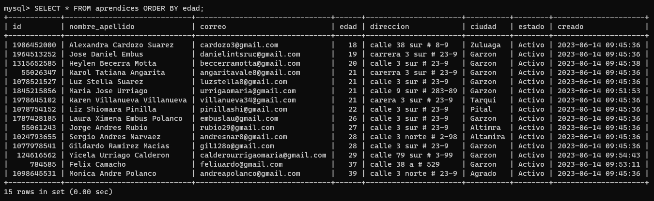

CASO 7: SELECT * FROM aprendices ORDER BY edad DESC;

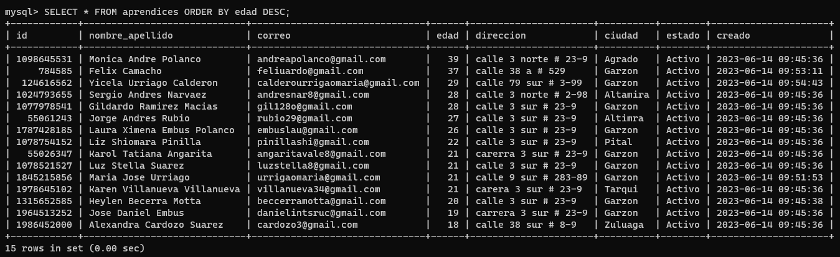

CASO 8: SELECT * FROM aprendices WHERE correo LIKE ‘%.com’;

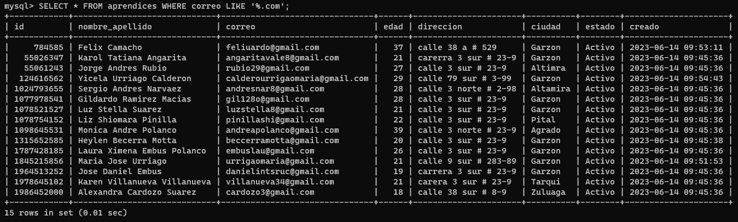

CASO 9: SELECT * FROM aprendices WHERE correo LIKE ‘an%’;

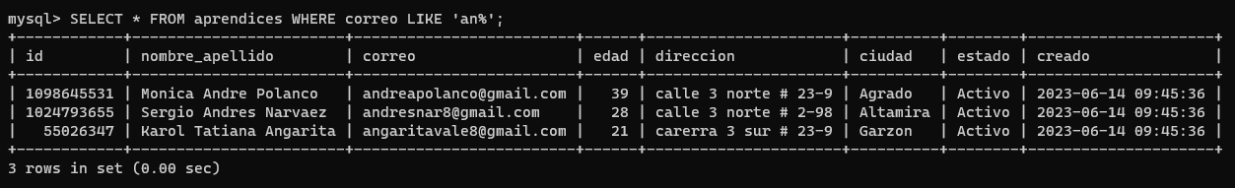

EJERCICIO 3: CRUD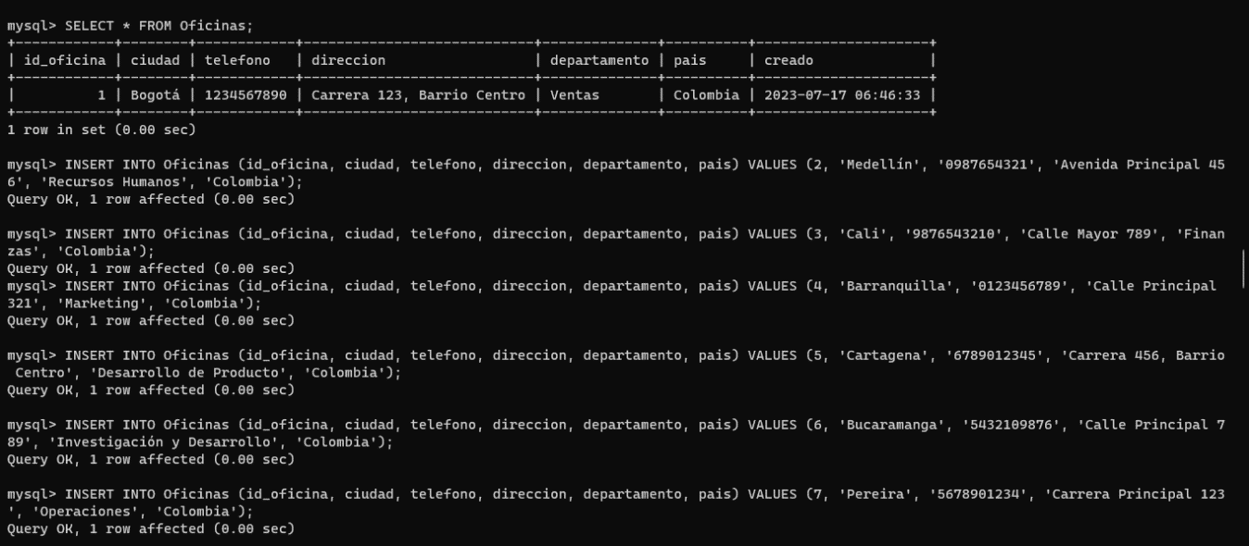

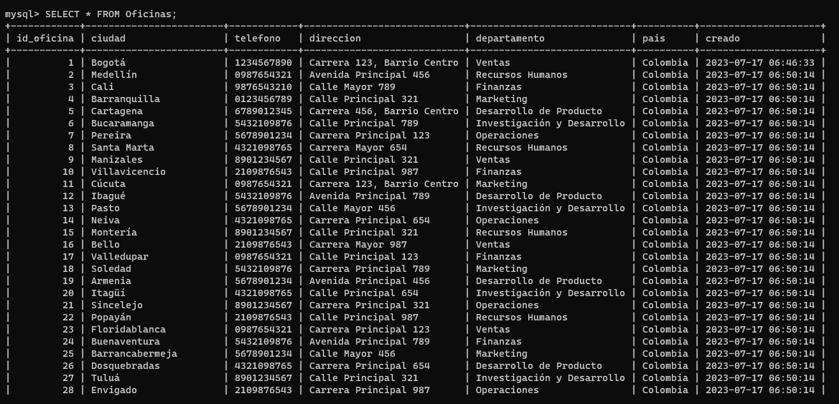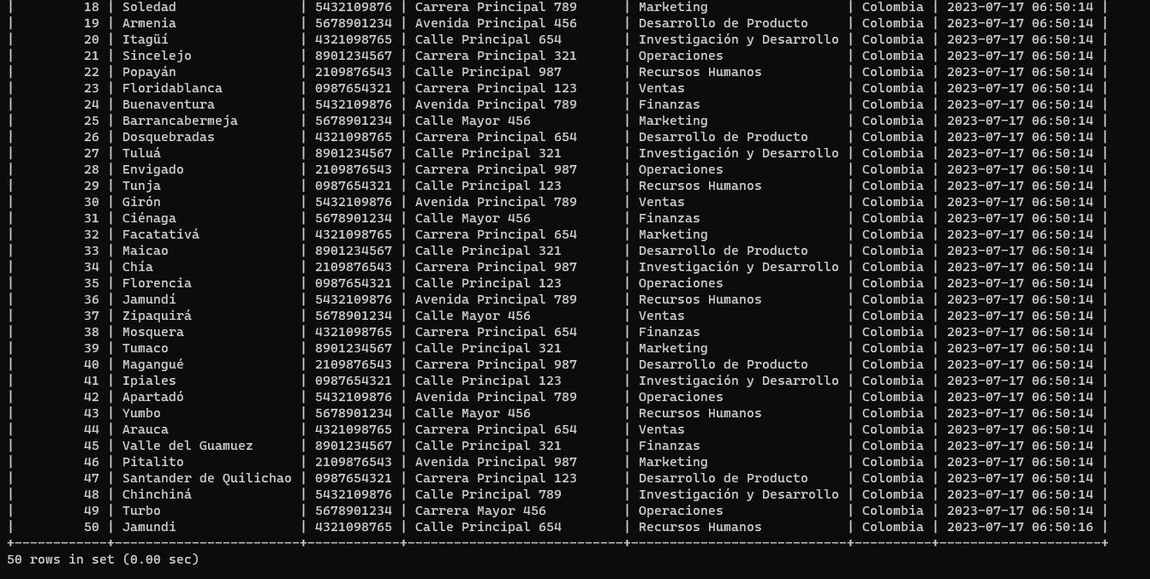

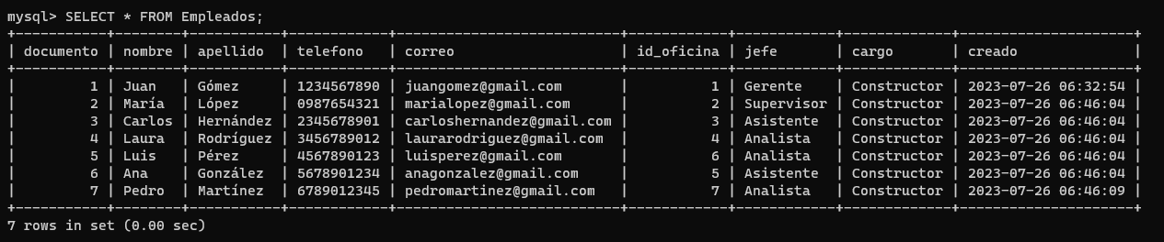

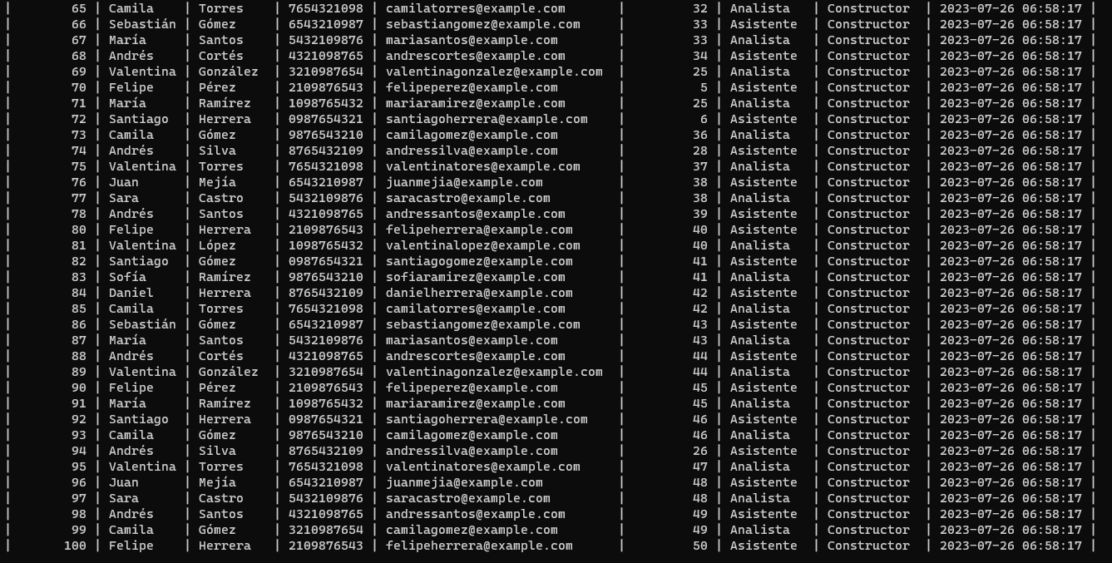

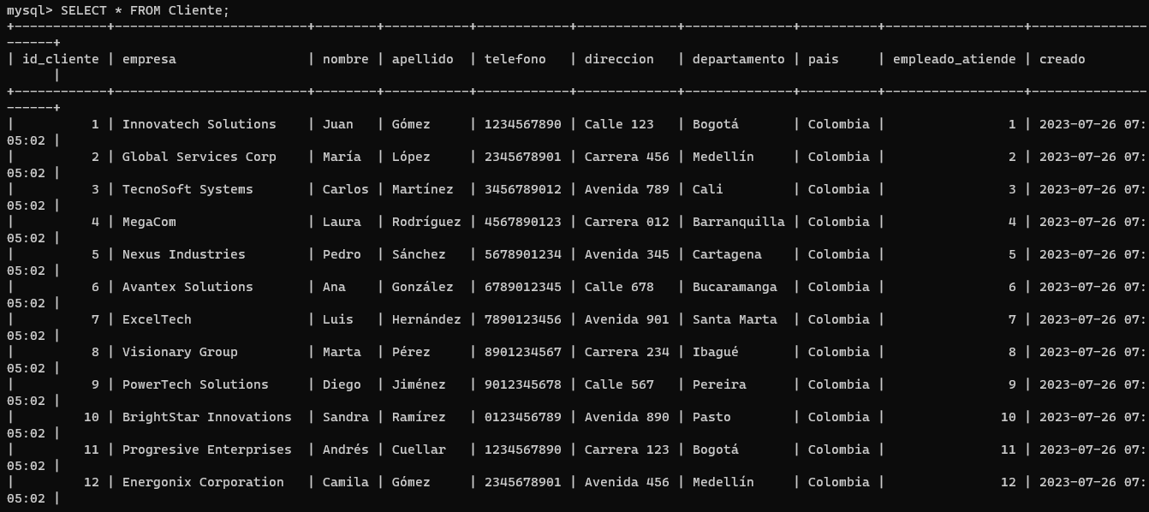

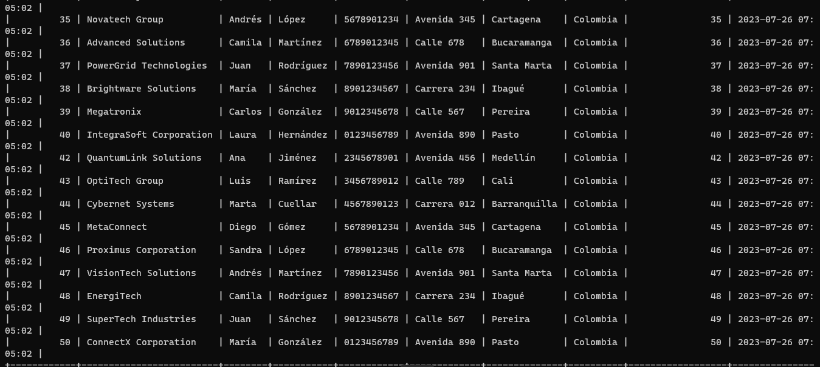

EJERCICIO 4: CRUD

